Task 2
Country-wise Cancer Stage Distribution
- Do different countries show different distributions of cancer stages at diagnosis?
- Create a stacked bar chart or normalized bar chart of cancer stages per country.

Output
- Terminal

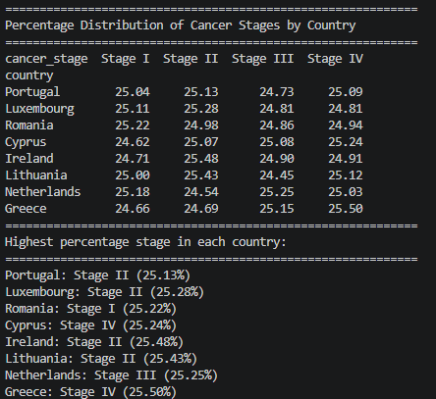

- Stacked Bar Chart (8 countries)
